Aaron L. Provins
CSD-325 – Programming with Python
Module 10 – Tkinter GUI To-Do Program
Grade Items: CSD-325 Discussion Board & CSD-325 Tkinter Program

Assignment Description
This module includes two graded components:
- CSD-325 Discussion Board – Participation completed in the LMS.
- CSD-325 Tkinter Program – This document and the included Python file represent the required Tkinter To-Do List program.
The program is based on Listing 2.2 “Our Scrolling To-Do” from Tkinter-By-Example and includes the required modifications:
1. Window title changed to Provins-ToDo
2. Menu bar added with two complementary colors
3. File → Exit menu item added
4. Tasks deleted using right-click instead of left-click
5. Label explains how to add and delete tasks
6. File / Edit / Help menus include example commands (Open, Save, Cut, Copy, Paste, About)

Screenshot 1 – Tasks Added

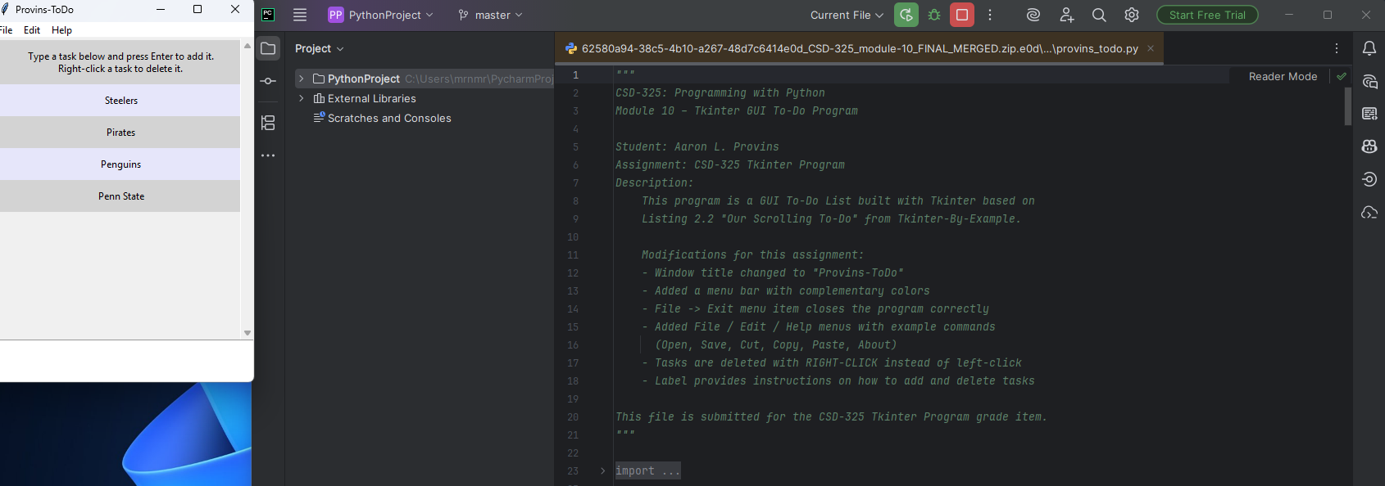

Screenshot 2 – Task Deleted
